Year 6
Autumn 1 Newsletter 2022

Meet the Team

Mrs Kaur-Griffiths Mrs Exley
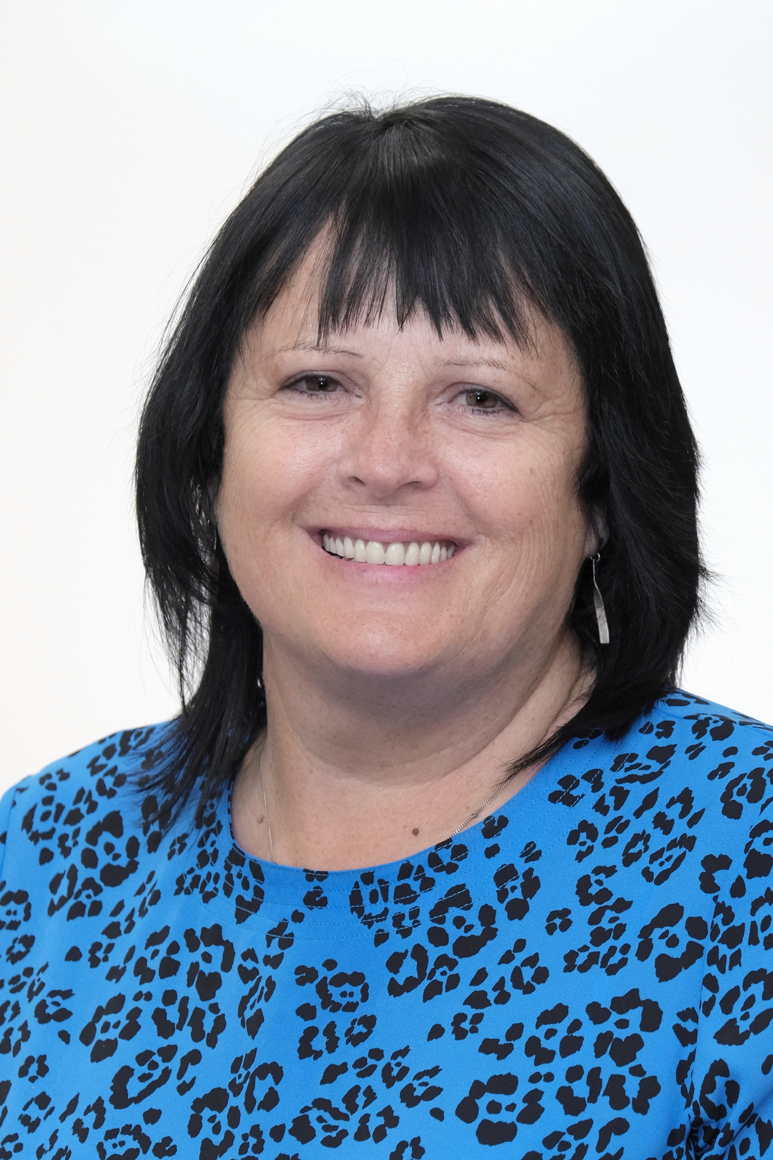

Mr Cresswell Miss Chapman
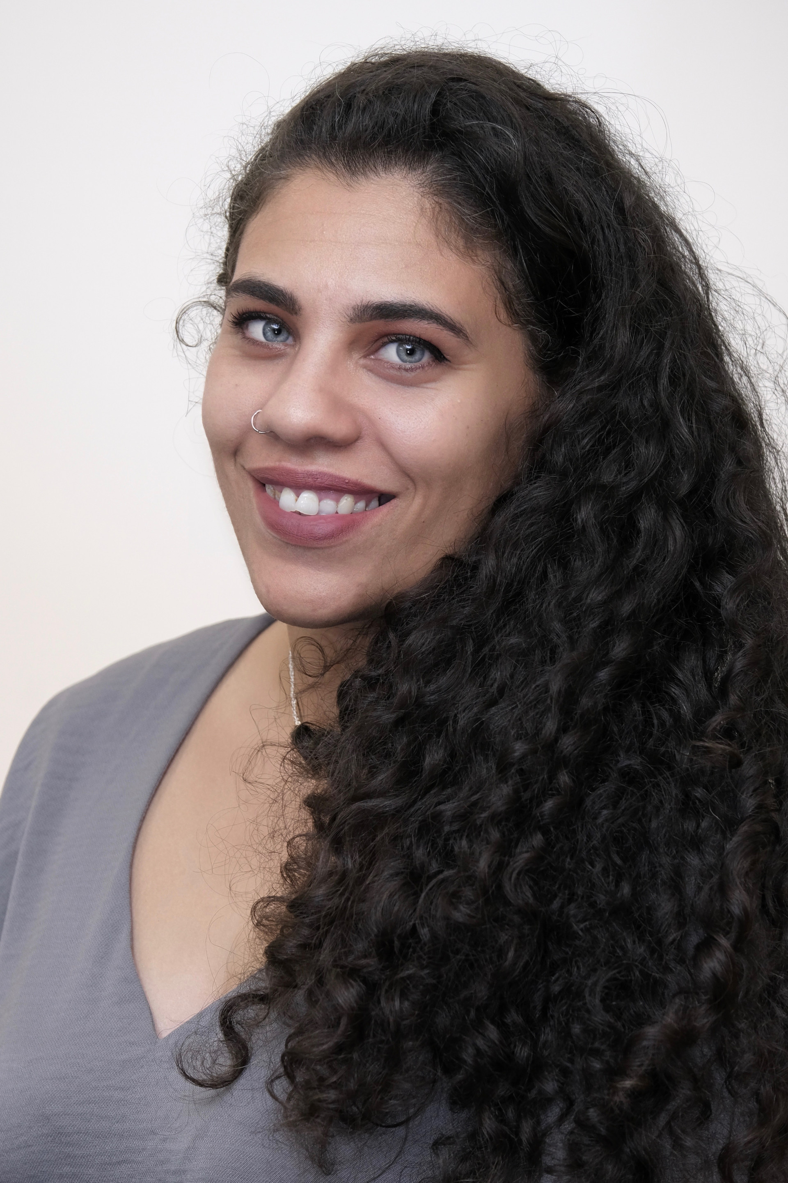

Returning to School
Welcome back to school – we hope you have had a restful summer break.
We have our meet the teacher session on the 5th and 6th September– we look forward to seeing you then.

Topic Overview & Key Text
We have developed a new thematic curriculum that creates meaningful links between the children’s learning in English, science, humanities and creative arts with our key text as the main driver.
Our topic work will focus on the lives of children during World War Two.

Humanities: In history we will be learning about World War 2- What impact did this war have on people’s lives in Manchester?
DT: We will be making an Anderson Shelter
Science: Electricity
PSHE: reconnecting with each other, British Values and Wider World etiquette and longstanding values that underpin our society.

Maths
This term we will be focusing on place value and the four operations-being able to apply this knowledge in different contexts is vital.

There is also going to a specific focus on fractions while continuing to revise our arithmetic skills.

Regular times table work will also be a focus.

Writing
Set in France, during the Nazi occupation of World War II, a gentile child named Helen recalls the mounting persecution of her Jewish friend. She wonders why does her best friend, Lydia, have to wear a yellow star? Why are people in hiding and using strange names? What is Lydia afraid of? Touching upon the Holocaust with sensitivity and poignancy, Star of Fear, Star of Hope will help readers understand this difficult event in history. We will be writing a flashback set in World War 2.

Reading
Our key theme in reading is World War 2, bravery, impact of war, bereavement and healing. We shall be reading the following texts: The Boy in the Stripped Pyjamas, Paz, Letters from the Lighthouse, Good night Mr Tom, Winter in Wartime, Erika’s Story and Skyward.

Homework
Monday – reading and spellings
Tuesday – reading
Wednesday – reading
Thursday -reading
Friday- PE Kit needed and spelling test

Daily reading. Reading journal signed by parent/carer at least 3 times a week.

Year 6
Date & Routines

Mondays | Tuesdays | Wednesdays | Thursdays | Fridays
Maths Homework due  Spellings tested  Reading daily | Reading daily | Reading daily | Reading daily | PE – please bring correct kit: black shorts, jogging bottoms or leggings; a plain PE top; a pair of trainers  Reading daily-reading records stamped.

We would like to welcome parents to meet their class teacher on either Monday 5th September or Tuesday 6th September at 9am or 3pm.

Conway Trip: Wednesday 14th – Friday 16th September

